
School Lane, Catforth, Preston PR4 0HL
CATFORTH PRIMARY SCHOOL
Website: www.catforthprimary.co.uk Fax: 01772 690451
Email: head@catforth.lancsngfl.ac.uk Tel: 01772 690451

Progression Towards a Written Method for Division
Agreed and developed in consultation with Mrs Bainbridge (Head Teacher), Mrs Drinkall (Maths Coordinator), Mrs Clitheroe (KS1 Maths Coordinator) and Mr Cameron (Class 3 Teacher) during Spring Term 2015.

In developing a written method for division, it is important that children understand the concept of division, in that it is:
- repeated subtraction
- sharing into equal amounts
They also need to understand and work with certain principles, i.e. that it is:
- the inverse of multiplication
- not commutative i.e. 15 ÷3 is not the same as 3 ÷ 15
- not associative i.e. 30 ÷ (5 ÷ 2) is not the same as (30 ÷ 5) ÷ 2

yr
Early Learning Goal:
Children solve problems, including halving and sharing.

Children are encouraged to develop a mental picture of the number system in their heads to use for calculation. They should experience practical calculation opportunities using a wide variety of equipment, including small world play, role play, counters, cubes etc.

Children may also investigate sharing items or putting items into groups using items such as egg boxes, ice cube trays and baking tins which are arrays.
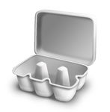
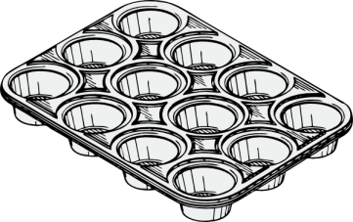

They may develop ways of recording calculations using pictures, etc.
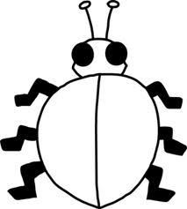
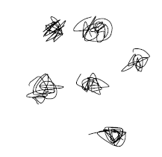
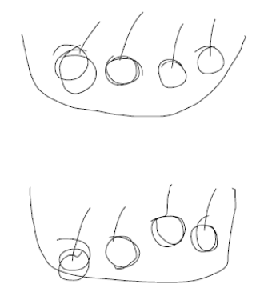
A child’s jotting showing halving six spots between two sides of a ladybird.

A child’s jotting showing how they shared the apples at snack time between two groups.

Y1
End of Year Objective:
Solve one-step problems involving division by calculating the answer using concrete objects, pictorial representations and arrays with the support of the teacher.

In year one, children will continue to solve division problems using practical equipment and jottings. They should use the equipment to share objects and separate them into groups, answering questions such as 'If we share these six apples between the three of you, how many will you each have? How do you know?' or ‘If six football stickers are shared between two people, how many do they each get?’ They may solve both of these types of question by using a 'one for you, one for me' strategy until all of the objects have been given out.

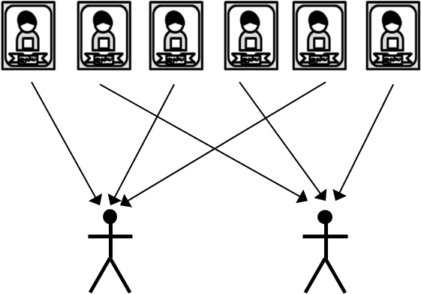

Children should be introduced to the concept of simple remainders in their calculations at this practical stage, being able to identify that the groups are not equal and should refer to the remainder as ‘… left over’.

Y2
End of Year Objective:
Calculate mathematical statements for division within the multiplication tables and write them using the division (÷) and equals (=) signs.

Children will utilise practical equipment to represent division calculations as grouping (repeated subtraction) and use jottings to support their calculation, e.g.

12 ÷ 3 =

Children need to understand that this calculation reads as 'How many groups of 3 are there in 12?'

They should also continue to develop their knowledge of division with remainders, e.g.

13 ÷ 4 =

13 ÷ 4 = 3 remainder 1

Y3
End of Year Objective:
Write and calculate mathematical statements for division using the multiplication tables that they know, including for two-digit numbers divided by one-digit numbers, progressing to formal written methods.*

*Although the objective suggests that children should be using formal written methods, the National Curriculum document states “The programmes of study for mathematics are set out year-by-year for key stages 1 and 2. Schools are, however, only required to teach the relevant programme of study by the end of the key stage. Within each key stage, schools therefore have the flexibility to introduce content earlier or later than set out in the programme of study.” p4

It is more beneficial for children’s understanding to go through the expanded methods of calculation as steps of development towards a formal written method.

Initially, children will continue to use division by grouping (including those with remainders), where appropriate linked to the multiplication tables that they know (2, 3, 4, 5, 8 and 10), e.g.

43 ÷ 8 =

43 ÷ 8 = 5 remainder 3

Children should be able to solve real life problems including those with money and measures.

Y4
End of Year Objective:
Divide numbers up to 3 digits by a one-digit number using the formal written method of short division and interpret remainders appropriately for the context.

Y5

Children will begin by learning to use simple chunking to divide 2 digit numbers by single digits.

72 ÷ 6 = 12
12

- 72
60 10 × 6
12
12 2 × 6
0
Answer is 12

Leading to the development of short division, to divide 3 digit numbers by a single digit number.

196 ÷ 6 = 32 r 4

3 2 r4
6 1 916

Children should be able to solve real life problems including those with money and measures. They need to be able to make decisions about what to do with remainders after division and round up or down accordingly. In the calculation 13 ÷ 4, the answer is 3 remainder 1, but whether the answer should be rounded up to 4 or rounded down to 3 depends on the context, as in the examples below:
-

I have £13. Books are £4 each. How many can I buy?
Answer: 3 (the remaining £1 is not enough to buy another book)

Apples are packed into boxes of 4. There are 13 apples. How many boxes are needed?
Answer: 4 (the remaining 1 apple still needs to be placed into a box)

Y5
End of Year Objective:
Divide numbers up to 4 digits by a one-digit number using the formal written method of short division and interpret remainders appropriately for the context.

Children will continue to use short division to divide 3 digit numbers moving onto dividing 4 digit numbers by one digit numbers.

196 ÷ 6 = 32r4

3 2 r4
6 1 916

4623 ÷ 5 = 924r3

924r3
5 461223

Children should continue to be able to solve real life problems including those with money and measures and simple decimals in context. They need to be able to make decisions about what to do with remainders after division and round up or down accordingly.

Y6
End of Year Objective:
Divide numbers up to 4 digits by a two-digit number using the formal written method of short division where appropriate, interpreting remainders according to the context.
Use written division methods in cases where the answer has up to two decimal places.

Children will be introduced to long division to divide 3 digit numbers by 2 digit numbers and will progress to learning to divide 4 digit numbers by 2 digit numbers.
6367 ÷ 28 =
227r11
28 6367
56 200× 28
767
56 20 × 28
207
196 7 × 28
11
432 ÷ 15 =

28r12
15 432
30 20 × 15
132
120 8 × 15
12
Children should be able to solve real life problems including those with money and measures. They need to be able to make decisions about what to do with remainders after division and round up or down accordingly including as a fraction or a decimal.

For simple fraction and decimal equivalents, this could also be demonstrated using a simple calculation such as 13 ÷ 4 to show the remainder initially as a fraction.

Using practical equipment, children can see that for 13 ÷ 4, the answer is 3 remainder 1, or put another way, there are three whole groups and a remainder of 1. This remainder is one part towards a full group of 4, so is . To show the remainder as a fraction, it becomes the numerator where the denominator is the divisor (the number that you are dividing by in the calculation).

3574 ÷ 8
446
8 3574
32 400 × 8
374
remainder
divisor
6
8
32 40 × 8
54
48 6 × 8
6

So 3574 ÷ 8 is 446
(when the remainder is shown as a fraction)

To show the remainder as a decimal relies upon children’s knowledge of decimal fraction equivalents. For decimals with no more than 2 decimal places, they should be able to identify:

Half: = 0.5
Quarters: = 0.25, = 0.75
Fifths: = 0.2, = 0.4, = 0.6, = 0.8
Tenths: = 0.1, = 0.2, = 0.3, = 0.4, = 0.5, = 0.6, = 0.7, = 0.8, = 0.9

and reduce other equivalent fractions to their lowest terms.
In the example above, 3574 ÷ 8, children should be able to identify that the remainder as a fraction of can be written as in its lowest terms. As is equivalent to 0.75, the answer can therefore be written as 446.75

